**The Best Indian Diet Plan for Weight Loss**

* [What It Is](https://www.healthline.com/nutrition/indian-diet-weight-loss#what-is-it)
* [Foods to Eat](https://www.healthline.com/nutrition/indian-diet-weight-loss#foods-to-eat)
* [Foods to Avoid](https://www.healthline.com/nutrition/indian-diet-weight-loss#foods-to-avoid)
* [Sample Menu](https://www.healthline.com/nutrition/indian-diet-weight-loss#sample-menu)
* [Healthy Snacks](https://www.healthline.com/nutrition/indian-diet-weight-loss#healthy-snacks)
* [How to Lose Weight](https://www.healthline.com/nutrition/indian-diet-weight-loss#how-to-lose-weight)
* [Shopping List](https://www.healthline.com/nutrition/indian-diet-weight-loss#shopping-list)
* [Bottom Line](https://www.healthline.com/nutrition/indian-diet-weight-loss#bottom-line)

Indian cuisine is known for its vibrant spices, fresh herbs and wide variety of rich flavors.

Though diets and preferences vary throughout India, most people follow a primarily plant-based diet. Around 80% of the Indian population practices Hinduism, a religion that promotes a vegetarian or lacto-vegetarian diet.

The traditional Indian diet emphasizes a high intake of plant foods like vegetables, lentils and fruits, as well as a low consumption of meat.

However, obesity is a rising issue in the Indian population. With the growing availability of processed foods, India has seen a surge in obesity and obesity-related chronic diseases like heart disease and diabetes ([1](https://www.ncbi.nlm.nih.gov/pmc/articles/PMC4613435/), [2](https://www.ncbi.nlm.nih.gov/pubmed/28601585)).

This article explains how to follow a healthy Indian diet that can promote weight loss. It includes suggestions about which foods to eat and avoid and a sample menu for one week.

**A Healthy Traditional Indian Diet**

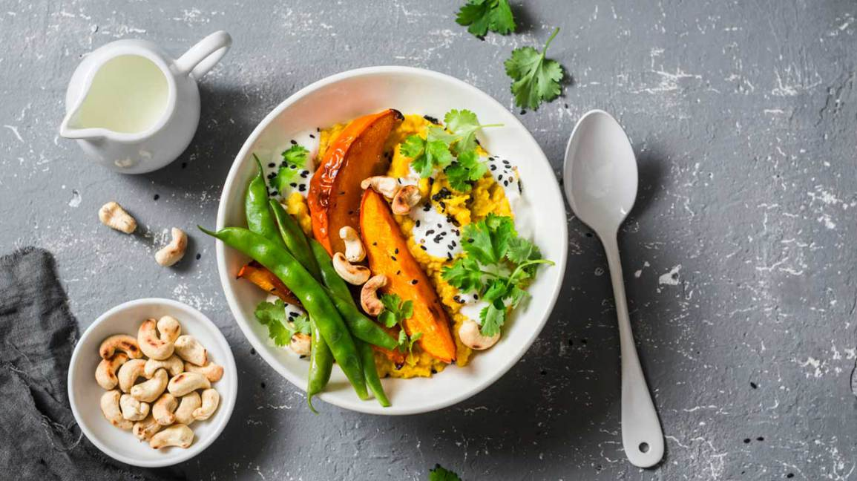Share on Pinterest

Traditional plant-based Indian diets focus on fresh, whole ingredients — ideal foods to promote optimal health.

**Why Eat a Plant-Based Indian Diet?**

Plant-based diets have been associated with [many health benefits](https://www.healthline.com/nutrition/vegan-diet-benefits), including a lower risk of heart disease, diabetes and certain cancers such as breast and colon cancer ([3](https://www.ncbi.nlm.nih.gov/pmc/articles/PMC4315380/), [4](https://www.ncbi.nlm.nih.gov/pmc/articles/PMC3048091/), [5](https://www.ncbi.nlm.nih.gov/pmc/articles/PMC5466941/)).

Additionally, the Indian diet, in particular, has been linked to a reduced risk of Alzheimer’s disease. Researchers believe this is due to the low consumption of meat and emphasis on vegetables and fruits ([6](https://www.ncbi.nlm.nih.gov/pubmed/27454859)).

Following a healthy plant-based Indian diet may not only help decrease the risk of chronic disease, but it can also encourage weight loss.

**What Food Groups Does It Include?**

The Indian diet is rich in nutritious foods like grains, lentils, healthy fats, vegetables, dairy and fruits.

The diets of most Indian people are heavily influenced by religion, particularly Hinduism. The Hindu religion teaches nonviolence and that all living things should be valued equally.

That’s why a lacto-vegetarian diet is encouraged, and eating meat, poultry, fish and eggs is discouraged. Lacto-vegetarians do, however, eat dairy products.

A healthy lacto-vegetarian diet should focus on grains, lentils, dairy, vegetables, fruits and healthy fats like coconut oil.

Spices such as turmeric, [fenugreek](https://www.healthline.com/nutrition/fenugreek), coriander, ginger and cumin are at the forefront of traditional dishes, adding rich flavor and powerful nutritional benefits.

Turmeric, one of the most popular spices used in India, is celebrated for its anti-inflammatory, antibacterial and anticancer properties ([7](https://www.ncbi.nlm.nih.gov/pubmed/26528921)).

[A compound in turmeric called curcumin](https://www.healthline.com/nutrition/top-10-evidence-based-health-benefits-of-turmeric) has been found to fight inflammation in the body, improve brain function and reduce risk factors of heart disease ([8](https://www.ncbi.nlm.nih.gov/pubmed/21986478), [9](https://www.ncbi.nlm.nih.gov/pmc/articles/PMC4754352/), [10](https://www.ncbi.nlm.nih.gov/pmc/articles/PMC3514766/)).

**SUMMARY**A healthy Indian diet focuses on lacto-vegetarian guidelines and emphasizes grains, lentils, vegetables, fruits, healthy fats, dairy and spices.

**Healthy Foods to Eat**

There are many delicious foods and beverages to choose from when following a lacto-vegetarian diet for weight loss.

**What to Eat**

Try incorporating the following ingredients into your daily meal plan:

* **Vegetables:** Tomatoes, spinach, eggplant, mustard greens, okra, onions, bitter melon, cauliflower, mushrooms, cabbage and more
* **Fruits:** Including mango, papaya, pomegranate, guava, oranges, tamarind, lychee, apples, melon, pears, plums, bananas
* **Nuts and seeds:** Cashews, almonds, peanuts, pistachios, pumpkin seeds, sesame seeds, watermelon seeds and more
* **Legumes:** Mung beans, black-eyed peas, kidney beans, lentils, pulses and chickpeas
* **Roots and tubers:** Potatoes, carrots, sweet potatoes, turnips, yams
* **Whole grains:** Brown rice, basmati rice, millet, buckwheat, quinoa, barley, corn, whole-grain bread, amaranth, sorghum
* **Dairy:** Cheese, yogurt, milk, kefir, ghee
* **Herbs and spices:** Garlic, ginger, cardamom, cumin, coriander, garam masala, paprika, turmeric, black pepper, fenugreek, basil and more
* **Healthy fats:** Coconut milk, full-fat dairy, avocado, coconut oil, mustard oil, olive oil, peanut oil, sesame oil, ghee
* **Protein sources:** Tofu, legumes, dairy, nuts and seeds

Meals and snacks should focus on fresh, whole foods flavored with [herbs and spices](https://www.healthline.com/nutrition/10-healthy-herbs-and-spices).

Additionally, adding non-starchy vegetables like greens, eggplants or tomatoes to your meals will provide a boost of fiber that can help you feel satisfied for a longer period of time after eating.

**What to Drink**

An easy way to cut back on excess calories and sugar is to avoid sugar-sweetened beverages and juices. These drinks can be high in both calories and sugar, which can [negatively affect weight loss](https://www.healthline.com/nutrition/liquid-sugar-calories).

Healthy beverage options include:

* Water
* Sparkling water
* Unsweetened tea including Darjeeling, Assam and Nilgiri teas

**SUMMARY**A healthy Indian diet should focus on fresh ingredients such as vegetables, fruits, tubers, legumes, whole grains, healthy fats and unsweetened beverages.

**Unhealthy Foods to Avoid**

Choosing foods and beverages that are highly processed, [loaded with sugar](https://www.healthline.com/nutrition/sugar-the-worst-ingredient-in-the-diet) or high in calories can sabotage your weight loss efforts.

Not only are items like candy, fried foods and soda not good for weight loss — they aren't good for overall health.

Eating too much processed food and products laden with sweeteners can increase the risk of chronic diseases.

For example, drinking sugar-sweetened beverages like soda, fruit punch and juices every day has been associated with increased risks of diabetes, obesity and heart disease ([11](https://www.ncbi.nlm.nih.gov/m/pubmed/25533007/)).

Plus, consuming unhealthy foods can make it harder for you to lose fat and maintain a healthy weight.

For optimal health, minimize the following foods or avoid them altogether:

* **Sweetened beverages:** Soda, fruit juice, sweetened tea, sweet lassi, sports drinks
* **High-sugar foods:** Candy, ice cream, cookies, rice pudding, pastries, cakes, sweetened yogurt, high-sugar cereals, digestive biscuits
* **Sweeteners:** Jaggery, sugar, honey, condensed milk
* **Sweetened sauces:** Salad dressings with added sugar, ketchup, barbecue sauce, sweetened curries
* **High-fat foods:** Fast food like McDonald’s, french fries, chips, fried foods, bhujia
* **Refined grains:** Products including white bread, white pasta, biscuits
* **Trans fats:** Margarine, vanaspati, fast food, highly processed foods
* **Refined oils:** Canola oil, soybean oil, corn oil, grapeseed oil

Although it’s perfectly fine to enjoy an occasional treat, limiting the foods and beverages listed above is best for overall health.

**SUMMARY**Avoiding sweetened beverages, fast food, fried items and products high in added sugar can help you lose weight and get healthier.

**A Healthy Indian Sample Menu for One Week**

Below is a healthy one-week Indian sample menu that focuses on fresh, nutritious food.

You can adjust it according to your calorie needs, dietary restrictions and food preferences.

**Monday**

* **Breakfast:** Sambar with brown rice idli
* **Lunch:** Whole-grain roti with mixed-vegetable curry
* **Dinner:** Tofu curry with mixed vegetables and a fresh spinach salad

**Tuesday**

* **Breakfast:** Chana dal pancakes with mixed vegetables and a glass of milk
* **Lunch:** Chickpea curry with brown rice
* **Dinner:** Khichdi with sprout salad

**Wednesday**

* **Breakfast:** Apple cinnamon porridge made with milk and topped with sliced almonds
* **Lunch:** Whole-grain roti with tofu and mixed vegetables
* **Dinner:** Palak paneer with brown rice and vegetables

**Thursday**

* **Breakfast:** Yogurt with sliced fruits and sunflower seeds
* **Lunch:** Whole-grain roti with vegetable subji
* **Dinner:** Chana masala with basmati rice and green salad

**Friday**

* **Breakfast:** Vegetable dalia and a glass of milk
* **Lunch:** Vegetable sambar with brown rice
* **Dinner:** Tofu curry with potato and mixed vegetables

**Saturday**

* **Breakfast:** Multigrain parathas with avocado and sliced papaya
* **Lunch:** Large salad with rajma curry and quinoa
* **Dinner:** Lentil pancakes with tofu tikka masala

**Sunday**

* **Breakfast:** Buckwheat porridge with sliced mango
* **Lunch:** Vegetable soup with whole-grain roti
* **Dinner:** Masala-baked tofu with vegetable curry

Drinking water, [seltzer](https://www.healthline.com/nutrition/club-soda-vs-seltzer-sparkling-tonic) or unsweetened tea with and between meals will keep you hydrated without adding extra calories.

Make sure to consume plenty of non-starchy vegetables at every meal, as well as sources of healthy fat and protein.

This will keep you feeling full throughout the day and reduce the chances of overeating.

**SUMMARY**A healthy lacto-vegetarian meal plan should be rich in vegetables, fruits, vegetarian protein sources and healthy fats.

**Healthy Snack Options**

Replacing high-calorie, sugary snacks with [healthier options](https://www.healthline.com/nutrition/29-healthy-snacks-for-weight-loss) can promote weight loss and help keep you on track towards your weight loss goals.

Like meals, nutritious snacks should revolve around fresh, whole ingredients.

Here are some weight loss friendly snack ideas:

* Small handful of nuts
* Sliced fruit with unsweetened yogurt
* Vegetable chaat
* Sprout salad
* Roasted pumpkin seeds
* Sliced fruit with nuts or nut butter
* Roasted chickpeas (channa)
* Hummus with vegetables
* Bean salad
* Salted popcorn
* Unsweetened kefir
* Homemade trail mix
* Fennel seeds
* Fresh fruit with cheese
* Broth-based vegetable soup

If you are craving a sweet snack to have with evening tea, swapping out your usual dessert for fresh, sliced fruit might do the trick.

For another healthy dessert option, top unsweetened yogurt with cooked fruit and crunchy nuts for a satisfying combination.

**SUMMARY**When choosing a snack, pick a nutritious option that is low in sugar and high in nutrients. Vegetables, fruit, cheese, nuts, seeds and unsweetened yogurt all make excellent snack choices.

**Smart Ways to Lose Weight**

Aside from focusing on fresh, whole foods, there are other lifestyle changes that can help you [lose weight](https://www.healthline.com/nutrition/how-to-lose-weight-as-fast-as-possible).

What’s more, adopting the following healthy habits can help you maintain a healthy weight over your lifetime.

**Increase Activity**

To create a calorie deficit that will help you lose weight, it’s critical to [increase the amount of activity](https://www.healthline.com/nutrition/how-to-start-exercising) in your day.

Find an activity that you enjoy, whether it be a sport or working out at the gym.

Even if you don’t exercise formally, try increasing the number of steps you take every day. It’s a simple way to burn more calories and get fit.

To lose weight, aim for a goal of 10,000 steps per day and work up to that goal over time.

**Practice Mindful Eating**

Many people eat on the run or consume meals while they’re distracted.

Instead, make a point to [focus on your meals and pay attention](https://www.healthline.com/nutrition/mindful-eating-guide) to feelings of hunger and fullness. It’s a great way to get more in tune with your body.

Eating more slowly can also promote weight loss by increasing feelings of fullness and decreasing hunger ([12](https://www.ncbi.nlm.nih.gov/pmc/articles/PMC4212566/)).

Another useful habit to control your food intake is to avoid eating in front of the television or while surfing the web.

**Make Smart Choices**

Eating healthy can be a challenge, so set goals ahead of time and stick to them.

This can help you maintain your plan, even when you are feeling tempted to make an unhealthy food choice, such as when you’re socializing with friends or family.

Reminding yourself why you want to get healthier in the first place can make you feel empowered and lead you to make smarter food and lifestyle decisions.

**SUMMARY**Being more active, practicing mindful eating and reminding yourself of your health and wellness goals are excellent tools that can help you stay on track.

**A Weight Loss Friendly Shopping List**

Having ingredients on hand to prepare nutritious meals and snacks at home is vital for weight loss.

So stock your refrigerator and pantry with healthy foods. It will motivate you to test out your cooking skills and try new recipes.

Research shows that people who cook more meals at home are more likely to have better overall diet quality, a healthier weight and less body fat than those who eat meals at home infrequently ([13](https://www.ncbi.nlm.nih.gov/pmc/articles/PMC5561571/)).

Here are some healthy items to add to your [shopping list](https://www.healthline.com/nutrition/healthy-grocery-list):

* **Vegetables:** Greens, cauliflower, herbs, carrots, peppers, garlic, eggplant
* **Fruits:** Apples, strawberries, mango, papaya, banana, grapes
* **Frozen produce:** Mixed vegetables and frozen fruits
* **Grains:** Oats, millet, quinoa, whole-grain breads, brown rice
* **Legumes:** Lentils, pulses, beans
* **Nuts:** Almonds, pistachios, cashews
* **Seeds:** Sunflower seeds, pumpkin seeds, lotus seeds
* **Dairy:** Milk, unsweetened yogurt, unsweetened kefir, cheeses, curd
* **Condiments:** Sea salt, pepper, turmeric, ginger, paprika, cinnamon
* **Starchy vegetables:** Potatoes, sweet potatoes, parsnip, pumpkin, corn
* **Proteins:** Tofu, dairy products, legumes, hummus
* **Healthy fats:** Olive oil, unsweetened coconut, coconut oil, ghee, sesame oil, avocado, peanut butter
* **Beverages:** Green tea, coffee, sparkling water, Darjeeling tea

Focus on filling your cart with fresh foods. These are usually stocked around the perimeter of the grocery store.

The shelves in the middle of the grocery store typically house packaged and processed foo